OBITUARY

Roger Cohen

DECEMBER 12, 1943 – JULY 18, 2022
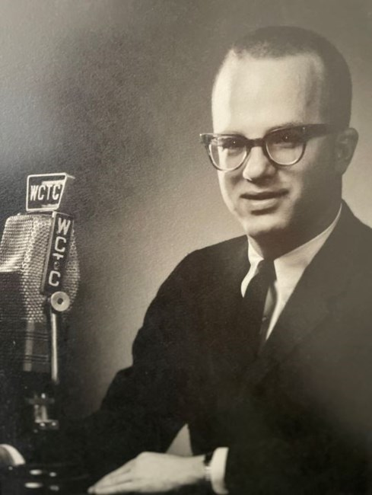

Roger Cohen 1943 - 2022
Roger Cohen (Pop Pop) passed away peacefully on July 18th, 2022.
He is survived by his wife of 54 years Debbie, his children Jonathan and Joanna, daughter-in-law Miroslawa Jablsonski-Cohen, son-in-law Robert Butler and his five grandchildren: Stephanie, Sarah, Matthew, Radek and Jonah.
He was born in Paterson, NJ where he attended Paterson’s Eastside High School. He attended Rutgers College and graduated in 1965 with a degree in English. After that, he worked as a news reporter for WCTC radio in New Brunswick, NJ. In 1969, he received his Master’s degree in radio and television from Syracuse University. Soon after that, he began his journey at Rutgers University, where he would remain for the duration of his career. Initially he worked as the coordinator of radio and television for the University. In 1976, he began teaching at the newly formed Department of Journalism and Urban Communications at Livingston College. He developed and taught Rutgers courses in Broadcast news writing, Radio production as well as TV programming. He worked and volunteered in many facets at Rutgers. He was the first on air play by play announcer for Rutgers Basketball. He was the moderator of the “The Rutgers Forum” public affairs show on WABC channel 7 and WNET Channel 13. His highlight being the program's 1500th show when he got to interview all four of New Jersey’s living governors. His favorite part of his job was his students though, some of whom he remained in contact with throughout his life. He retired from Rutgers in 2003. Roger had a gigantic sense of humor and loved to sing at any opportunity. He will be greatly missed.
There will be a graveside funeral for Roger on Wednesday, July 20th at 11:00am at Mount Lebanon Cemetery, 189 Gill Lane, Iselin (Woodbridge), NJ 08830 immediately followed by a burial.
Shiva will be observed at the residence Roger and Deborah shared on Wednesday following the burial until 8:00pm and on Thursday 1:00pm - 7:00pm.
The family asks that in lieu of flowers, any donations to be made to the Special Olympics (www.specialolympics.org).
Fond memories and expressions of sympathy may be shared at www.bloomfieldcoopermanalapan.com for the Cohen family.

