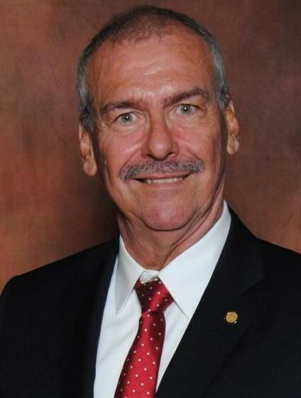

Robert Szejner
Dr. Robert Szejner, 68 of Lawrenceville passed away peacefully surrounded by his loving family, on Saturday, June 17, 2023 after a courageous battle with cancer. Born in Trenton, Bob resided in Lawrenceville NJ. Bob started his career in 1974 when he joined the Trenton Police Department. He retired in 2002 as a Lieutenant after 28 years of dedicated service. Bob went on to further his education and received his Doctorate of Education from St. Joseph’s University. He recently celebrated 16 years teaching at Rutgers University as a Professor of Criminal Justice up until his death. Bob’s smile could light up a room. He had a kind, compassionate, and giving heart. His grace and dignity through his battle was unmeasurable. Our heartfelt thank you to the team on 2North at Capital Regional Trauma Center for all your support, professionalism and caring for Bob. You girls know who you are. You are the Best. Son of the late Francis and Mary Szejner, brother of the late Richard and Frank Szejner, and brother-in-law to the late Ellie Downs, he is survived by his loving wife of 21 years, Janet; two daughters, Christina Guida and her husband Colin, Lauren Szejner and her significant other John McGlynn. Stepsons Christopher Ciccone and his wife Andrea and Daniel Ciccone and his wife Lisa. Five Grandchildren, Dominic and Liam Guida, Mia and Joey Ciccone and Sara Ciccone, Brother Ron Szejner and his wife Sandra, sister-in-laws Mary Szejner and Mary Elliott and her husband Mel, Brothers-in-law, Jeffrey Downs and Robert Skorupa and his wife Judy as well as many nieces and nephews. Funeral services will be held Friday June 23, 2023 at 11:00 a.m. at Poulson & Van Hise Funeral Directors, 650 Lawrence Road, Lawrenceville, NJ 08648. Interment will be held at St. Hedwig Cemetery, Ewing, NJ. The visitation for Bob will be held Thursday evening from 5-8pm and again on Friday morning from 10:00-11:00 am at the funeral home. Lawrence Road Fire Company, Station 22 will conduct memorial services at 7 PM. In lieu of flowers, memorial donations can be made to the American Cancer Society (pancreatic cancer) or TASK Task.charityproud.org

