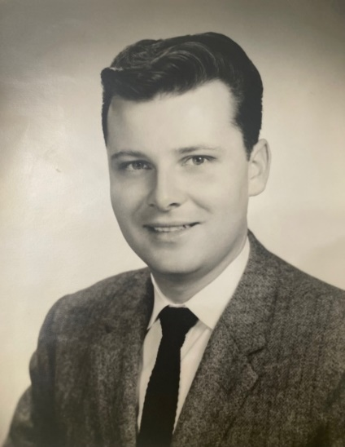

Richard F Kenny
January 28, 1935 ~ May 12, 2023 (age 88)

Richard F. Kenny, 88, of Edison and formerly of Perth Amboy died on May 12, 2023. For 62 years, he was the husband of Dolores R. (Laskoski) Kenny.
Richard was born in Perth Amboy, NJ on January 28, 1935, one of five children of the late Francis Kenny and Elsie (Mankovich) Kenny. He was raised in Perth Amboy, served in the United States National Guard, and was a graduate of Fairleigh Dickinson University with a degree in Chemistry.
Married in 1961, he and Dolores made Edison their home for more than 50 years, where they raised their three children. Richard had been employed by Engelhard Corporation, Cincinnati Milacron,Stauffer Chemical, and worked the final 22 years of his career at Rutgers University in New Brunswick.
He enjoyed his home, music, woodworking, tinkering with his tools, reading the newspaper, and spending time with his family. He was a member of St. Helena Church of Edison.
He is survived by his wife, Dolores Kenny, and three children Christine Durko, and her husband Tom of Edison; Rich, and his wife Michele of Hillsborough; and Kathleen, and her husband Dan of Maryland; five grandchildren: Thomas, James, Kevin, Jillian, and Kyle; sisters Jean Kenny of Connecticut and Eileen Hanick, wife of Jack Hanick of Farmingdale; and brother James Kenny, husband of Helene of Monroe. Robert Kenny, husband of Brenda of Farmingdale.
His funeral service will be on May 27 at 10:30 am at St. Helena Church in Edison, NJ. Family and friends respectfully welcomed.

