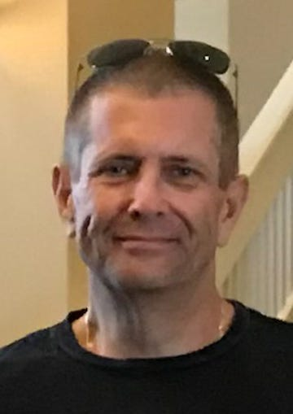

Obituary

Peter Kevin Pelletier died Wednesday, August 17, 2022, in Florida. He was 66. Born in New Brunswick to the late Arnold “Frenchy” and Maddalena “Lena” (Romeo) Pelletier, he lived in Edison and North Brunswick before moving to Florida in 2015. He graduated with honors from the Union County Police Chiefs Training Academy and served the Rutgers Police Department New Brunswick for 35 years retiring as a lieutenant in 2007 and then as an Office of Emergency Management Specialist, where he assisted in planning and managing special events, in 2012. He was a forward thinker who strived to problem solve issues such as drug and alcohol abuse. He developed RCAT, which is considered a national model for police agencies regarding law enforcement drug court participation. He believed in dignity, patriotism, and leadership excellence. Peter was giving of himself without reservation. In teaching he provided the tools for individuals to accomplish their dreams. Lt. Pelletier was a member of the Fraternal Order of Police Lodge #164, the Fraternal Order of Police Grand Lodge and the New Jersey Retired Police and Firemen’s Florida Local #22. He was a communicant of St. Mary of Mount Virgin R.C. Church in New Brunswick and was an Exempt Life Member of the North Brunswick First Aid and Rescue Squad. Surviving are his wife Patricia (Lisa) Pelletier; several cousins, nieces and nephews. Visitation will be 4:00 PM to 7:00 PM Thursday, August 25, 2022, at Selover Funeral Home, 555 Georges Road, North Brunswick. Funeral services will be 9:45 AM Friday, August 26, 2022, from Selover Funeral Home followed by a 10:30 AM Mass at St. Mary of Mount Virgin Church in New Brunswick. Entombment will follow in Franklin Memorial Park in North Brunswick. Contributions in Peter’s name may be made to St. Jude Children’s Research Hospital, 501 St. Jude Place, Memphis, TN 38105 (www.stjude.org) or to North Brunswick First Aid and Rescue Squad, 880 Ridgewood Avenue, North Brunswick, NJ 08902 (www.nbfars.org) or to the National Law Enforcement Officers Memorial Fund (nelomf.org).

