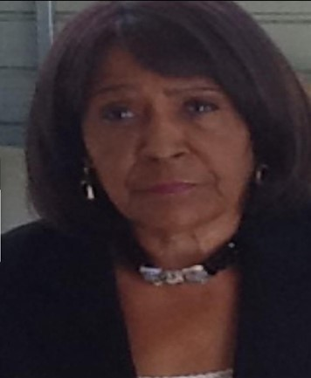
Laura A. Hicks
January 4, 1944 ~ June 20, 2023 (age 79)

Obituary
On June 20, 2023, Laura A. Hicks passed away at Sovah Hospital in Danville VA. She was surrounded by her
family.
Laura was born in Milton, NC, to the late Hudson and Dorothy Hicks.
She worked for Rutgers University Police Department in Newark NJ. for twenty-five plus years as a security officer.
While there, she received many honors and distinguished awards for her alertness and leadership skills. She was
well respected and liked by all. A loving and devoted mother who dedicated her life to taking care of her daughters
and grandson. In her spare time, she enjoyed gardening and playing with her great-granddaughter.
Laura was preceded in death by a brother Hurley and a sister Doris. She is survived by her loving daughters Michelle and Yolanda, grandson Tharien "TT”, and precious great granddaughter Journey. Sisters and brothers Arnedia, Sadye, Roecina (John), Angela, Ronnie, Darrell, Jacqueline, and Mark along with a host of nephews, nieces, cousins, and friends.
A memorial service will be held at:
Wilson Funeral and Cremation Inc.,
179 Piney Forest Road
Danville, VA,
July 8, 2023, at 3:00 pm.
Flowers can be sent directly to Funeral Home

