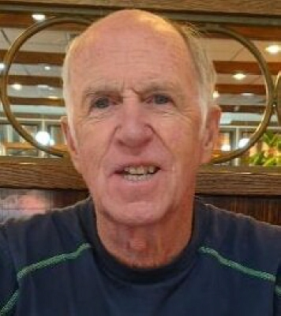

Kevin Cecil Barry
September 27, 1948 - December 10, 2022

Obituary
Kevin Barry of Monroe Township died Saturday, December 10, 2022, surrounded by family. He was 74.

Kevin was born September 27, 1948, in New Brunswick, NJ while his dad was building their home next door to Tara Greens Golf Course in Somerset. The Barry brothers learned to golf there and played often. He, like most of his brothers, worked at the course as a young person where he made many lifelong friendships. He attended St Peter's in New Brunswick for grade school through high school, graduating with the class of 1966. He had fond memories of his school years and his classmates. Kevin worked his way through college and graduated from Newark State College (now Kean University) in 1972.

He met the love of his life, Linda (nee Hefner) March 15, 1978. They married on September 21, 1980. Each year on the anniversary of their first date, they would return to the site of the restaurant where they met, now LaTaverna, Dayton, NJ. Occasionally, they had to resort to eating a sandwich in the parking lot if the restaurant was closed. They celebrated their 40th wedding anniversary during the pandemic in 2020 receiving dozens of postcards from family and friends expressing their love, congratulations and a personal sentiment or memory.

Kevin worked as a golf professional at the Rutgers University Golf Course for 35 years, retiring in 2014. Kevin and Linda raised their three children, Jennie, Kian and Kyle while living in East Brunswick for 34 years. They moved to Monroe Township in 2017 and enjoyed meeting many new friends. Spending time with family and friends was Kevin's favorite pastime, especially when it included his brothers. He enjoyed travel, live theater and music, especially the Moody Blues and Irish music. He loved most sports and attended many Rutgers football, basketball and soccer games over the years. His love of children was a beautiful thing to see. Kids loved how he made them laugh with tricks, animal sounds, dance moves, rolling his eyes,or just being silly.

Kevin was predeceased by his loving parents, William and Cecilia (O'Shaughnessey) Barry, and brothers John (infant) and Peter, a brilliant and beloved professor at the University of South Carolina, as well as his sister-in-law, Shirley Hefner, who admired him greatly. Kevin is survived by his devoted wife Linda and their children: Jennie & Lynn Mattila, Kian Barry & Shelly Rzewuski, and Kyle Barry; and by his brothers: (William) Brian & wife, Kay (Katherine) Shaun, Kelly & wife, Denise and Kerry & wife, Carolyn and his sister-in-law, Mary of Lancaster SC. He is also survived by his Hefner in-laws, Don and Dot, Frank and Karen (Herr), Marni (MaryAnn), and Joy & Bob Kurczeski, as well as dozens of nieces, nephews, great-nieces, great-nephews, cousins, and two beautiful foster twin grandsons who have brought the family so much joy this past year!

Kevin was a kind, unselfish, generous and fun-loving man with a great sense of humor and a quick wit. He is already greatly missed and was loved and respected by those who knew him well.

A memorial service is planned for Wednesday, December 28 at St. Bartholomew's Church in East Brunswick at 11am. A cheerful celebration of life at a local restaurant will follow. All are welcome.

Kevin's favorite charities were Covenant House and St. Jude's Children's Hospital, if considering a donation in his honor.

