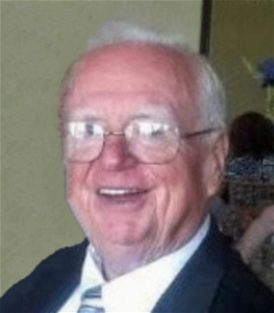
BROUGHT TO YOU BY GLEASON FUNERAL HOME
James G. Moran, age 87, passed away peacefully surrounded by his loving family on Thursday, July 20, 2023, at his home in Monroe, NJ. He was born on February 10, 1936, in New Brunswick, NJ, to the late Daniel and Ethel (Seymour) Moran. James (aka “Red” or “Bingo”) had a full and fulfilling life, leaving behind a legacy of love, dedication, and cherished memories.
James grew up in New Brunswick and had the privilege of living in several communities, including Milltown, Neshanic, Whiting, and Monroe. He was a graduate of St. Peter's High School in New Brunswick, where he played football under the legendary coach, Bud Murphy. It was at St. Peter's as sophomores in 1953 that he met the love of his life, Evelyn Moran, whom he cherished deeply. Together, they shared 66 wonderful years of marriage.
Proud of his Irish heritage, James was a member of a few Irish clubs, cherishing the cultural ties that connected him to his roots. He was also a devoted parishioner of St. James the Less Church in Jamesburg.
James embarked on a career at Gates Rubber in New Brunswick before becoming a painter at Rutgers University. Being an avid Rutgers fan, James proudly held season tickets for 31 years. Outside of work, he had a passion for woodworking and often lent his skills to his children's homes, earning the title of the family's go-to handyman. His children would lovingly save projects for him, knowing how much he cherished these moments. He would smile and jest, insisting they leave some work for him, as he relished the opportunity to help his family. Another significant aspect of James’s life was his passion for the card game 500 Rummy. He was a true master of the game, with unmatched expertise that impressed everyone who had the privilege of playing with him. But his greatest joy came from teaching the game to the entire family. Patiently, he passed on his knowledge, skill, and love for 500 Rummy to each family member, making it a cherished tradition. James also loved numerous visits to Florida, where he and his wife spent 21 winters crafting cherished memories at their beloved St. Petersburg home.
He will be fondly remembered as a devoted husband, a loving father, an adoring grandfather, a beloved great grandfather, a caring brother, and a loyal friend. His warm presence and kind-hearted nature left a lasting impact on those around him, and he will be greatly missed by many.
James was preceded in death by his brothers, Daniel and Richard Moran.
He is survived by his beloved wife, Evelyn (O’Neill) Moran of Monroe, and their children: Thomas Moran and his wife Maureen of Doylestown, PA; Eileen Moran of Robbinsville, NJ; Ann Marie Angelucci and her husband Louis of Yardley, PA; Terence Moran and his wife Darleen of Milltown, NJ; and Tara Jakubowski and her husband Robert of Hillsborough, NJ. James also leaves behind ten grandchildren: Katie, Erin, Timothy, Kelly, Louis, Matthew, Michael, Carolyn, Kate, and Connor; as well as five great-grandchildren: Maggie, Finnegan, Gavin, Molly, and Shannon. He is also survived by a host of extended family members and friends who were touched by his loving spirit.
Family and friends are invited to pay their respects on Monday, July 24, 2023, from 3:00 to 7:00 P.M. at the Gleason Funeral Home, located at 1360 Hamilton Street, Somerset, NJ 08873.
A Mass of Christian Burial will be celebrated at 10:00 A.M. on Tuesday, July 25, 2023, at St. James the Less Church in Jamesburg. We kindly ask everyone to arrive at the church by 9:45 A.M. Following the service, James will be laid to rest at Holy Cross Cemetery in East Brunswick.
In lieu of flowers, the family kindly requests that donations be made in James G. Moran's memory to St. Jude’s Childrens Hospital at www.stjude.org/donate or to the Dravet Syndrome Foundation, Inc at www.dravetfoundation.org/donate.

