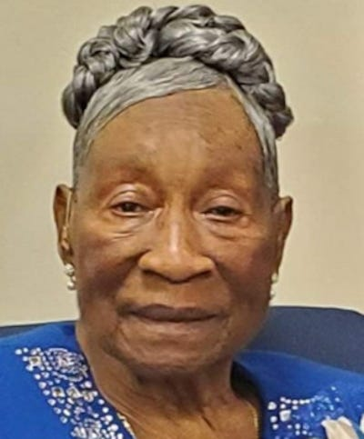

Evelyn Walker
Franklin Twp. - Loving mother, Evelyn Walker, 85, born October 14, 1936 in Kokomo, MS, entered eternal rest January 25, 2022. Daughter of the late Elizabeth Williams and Junior Bishop Matthew Brown, she was married to the late Clarence Walker for over 50 years. A longtime resident of New Brunswick, NJ, she retired from Rutgers University after over 15 years. A Missionary of Mt. Zion First Born Church of the Living God, she later became a Minister. She was most known for her amazing cooking. Left to cherish her memory: 3 siblings, 9 children, 20 grandchildren, 12 great grandchildren and many others. Funeral services will be be Thursday, February 10, 2022 at Abundant Life F.W.C, 259 George Street, New Brunswick. Viewing, 10am; Funeral, 11am.

