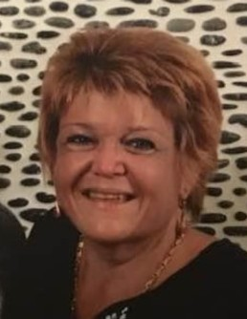

Erin M. (O'Leary) Williams
July 8, 1966 ~ April 3, 2022 (age 55)

Obituary
Erin M. Williams of Monmouth Junction, NJ passed away on April 3, 2022 at St. Peters Medical Center, New Brunswick. She was 55 years old. Born in New Brunswick, Erin was a resident of Milltown, NJ until marrying and relocating to Monmouth Junction in 1991. She was employed in Dining Services by Rutgers University for 28 years until retiring in 2020. Erin was a lifetime member of the Milltown Rescue Squad. She loved to travel, particularly by cruise ship to the Caribbean to dip her toes in the warm tropical waters. In addition, as long as she had a chair and umbrella, you’d often find Erin, drink-in-hand, beachside at the Hard Rock in AC.
Predeceased by her father Henry in 1991, mother Jacqueline in 2001, brother Mike in 2011, and step-father John in 2013; Erin is survived by her beloved husband Cliff, son Brandan, brother Sean, and many loving friends.
Family and friends will be received on Thursday, 4-8pm at the Bronson and Guthlein Funeral Home of Milltown, NJ. The funeral mass will be celebrated Friday, 10am at St. Cecelia RC Church, Monmouth Jct. with entombment to follow at Holy Cross Burial Park, Jamesburg, NJ.
In lieu of flowers, memorial donations may be made to the Milltown Rescue Squad, PO Box 308, Milltown NJ 08850.

