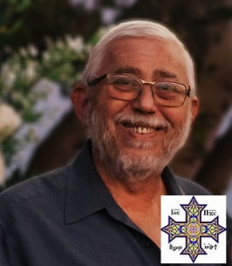
In Loving Memory of DR NAGY HANNA MIKHAIL
The Mikhail family is heartbroken to announce the passing of their beloved Dr Nagy Mikhail.
Dr Mikhail of Jackson, NJ passed away on Thursday, June 9, 2022. He is survived by his loving family:
Devoted husband of Cherine Mikhail
Cherished father of Mary Jo Mikhail and Daniella Mikhail, fiancée of Andrew Shehata
Beloved Brother of Nagwa Mikhail and Magdy Mikhail, Husband of Mary Mikhail
Adored Uncle of Mark Mikhail, Husband of Veronia, and David Mikhail, Sandra Makar, Wife of Mark Yousry, Youssef Makar, and Emma and Jenna Guirguis
Admired Brother-in-law of Ihab Makar, husband of Dalia Makar and Ingy Guirguis, wife of John Guirguis
There will be a CONDOLENCE service on Friday, June 10, 2022 starting at 7pm until 9pm at Archangel Michael Coptic Orthodox Church, 7 Church Road, Howell, NJ 07731. The FUNERAL SERVICE and Prayers will be on Saturday, June 11, 2022 at 9:00am immediately after the Divine Liturgy of the Believers which shall start promptly at 7:30AM at Archangel Michael Coptic Orthodox Church, 7 Church Road, Howell, NJ 07731.
The INTERMENT will be at Franklin Memorial Park immediately following the funeral prayers. The family invites all to celebrate a meal of love (Agape) in honor of our beloved Dr Nagy Mikhail at St Mary Coptic Orthodox Church, 433 Riva Ave, East Brunswick, NJ 08816 in the Fr Bishoy Fellowship Hall located on the main level.
May the Lord repose his soul in peace in the Heavenly Jerusalem in the bosom of our Fathers Abraham, Isaac and Jacob.
Funeral arrangements are under the respectful care and direction of Ruby Memorial Funeral Home of North Brunswick, NJ. Memories and condolences may be shared at www.rubymemorialhome.com.

