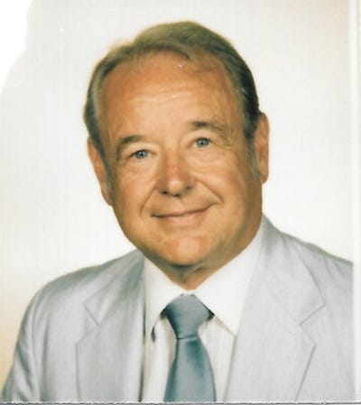

Dr. Joseph J. Soporowski, Jr.
Lakewood - Dr. Joseph J Soporowski, Jr., 93, of Lakewood, (formerly of Mantoloking, Marlboro, and Perth Amboy) passed away on May 4, 2022.
Joseph, the son of Joseph and Angelline Soporowski was born in Perth Amboy NJ on May 4, 1929. Dr. Soporowski had a unique professional background
Serving in both the public and private sectors. After graduating as the Scholar Athlete from Perth Amboy High School in 1947, he attended Rutgers University, earning a bachelor of science degree. After graduation, he served with honor as an officer in the United States Air Force Strategic Air Command. His final active assignment was with the USAF's School for Survival in Nevada. Upon leaving the military, he earned his MBA and worked nine years, gaining valuable experience in the petroleum industry with Chevron before accepting the position of Deputy Mayor of Perth Amboy, NJ where he developed and directed the City's Department of Air Pollution Control. Several years later, Rutgers University hired him as a tenured Professor of Environmental Sciences and full-time member of their faculty. Dr. Soporowski earned his doctorate in education through Rutgers and went on to develop and teach numerous courses for the school's Department of Environmental Sciences. Through his relentless work with nonprofit organizations such as the Water Environment Federation, Noise Control Association, and Air and Waste Management Association (where he served as the AWMA President in 1985-86), he proved his sincere dedication to improving the environment and promoting education for sustainability. Beloved by his students and well-respected by his colleagues, he eventually retired as Professor Emeritus and has since been honored as a "Loyal Son of Rutgers." As the Class of 1951 President, he worked closely through the years with the Rutgers University Foundation and most recently, helped raise the funds necessary for the development and construction of the Rutgers Visitor Center. Dr. Soporowski would later serve as President and CEO of Environet, Inc. and most recently, an invaluable consulting partner with Sustainable Education Associates. During his illustrious career, Dr. Soporowski has received a multitude of achievement and service awards. Most notably, Dr. Soporowski was made a Life Member of the Air & Waste Management Association as well as the New Jersey Water Environment Federation where he served as Editor for various publications for many years.
Dr. Soporowski is survived by his loving children, Cheryl Grobelny, Nancy Jo Soporowski, and Joseph Soporowski III; childrenin-law, Ed Grobelny, Vito Palombella, and Judith Soporowski; grandchildren, Erik and Adam Grobelny, Emily and Vito Palombella; and great grandchildren Griffin, Ethan, and Nathan Grobelny. He is reunited in death with his beloved wife of 67 years, Lillian B. Soporowski.
Visitation will be held Tuesday, May 10, 2022, from 2:00 pm - 4:00 pm and 6:00 pm - 8:00 pm at the Waitt Funeral Home, 501 Hwy, 79, Morganville, NJ.
Funeral services will be held on Wednesday, May 11, 2022, 10:00 am at St. Dominic Roman Catholic Church, 250 Old Squan Rd., Brick, NJ.
Burial will follow in the St. Rose of Lima Cemetery, Freehold, NJ.
In lieu of flowers, the family suggests donations in Joseph's memory to the Dr. Joseph J. Soporowski Scholarship, Rutgers University https://give.rutgers.edu/SoporowskiMemorial

