Joel Wayne Goldsmith

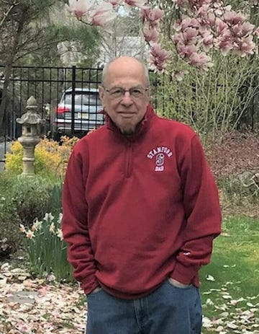
Joel Wayne Goldsmith born May 11, 1943 in New York City passed away peacefully on December 7, 2022, at the age of 79 surrounded by his loving family after a courageous, and extended battle against cancer. He is survived by his life partner of 31 years Sarah Wasserman, his two children, Michelle and Jonathan, his sister Deborah, brother Daniel, and his grandson, Jason. Joel attended the prestigious Bronx High School of Science and earned his undergraduate degree from Columbia University, and his medical degree at SUNY down state. He completed his medical internship at Long Island Jewish Hospital, followed by his residency at Montefiore and Albert Einstein Hospitals. After his surgical training, Joel served as a Major in the US Army, spending two years in active duty with one of those in Vietnam. He opened a Urology practice in East Brunswick and ran it successfully solo for 48 years before becoming an assistant professor at Rutgers Medical School for the last 15 years. He was a beloved faculty member and mentored dozens of urology residents winning multiple teaching awards. Joel had a green thumb and a passion for nurturing not only surgeons but his garden. He took great pride in his 2-acre property. He was a born horticulturist. In addition to amassing many beautiful plants, he was also an avid collector of art and antiques. He spent many holidays and weekends attending Antique Shows with Sarah. They shared a passion for traveling and going to classical concerts and operas. Intellectually he was extremely gifted and had a tremendous appetite for reading anything from the New York Times to his favorite science fictions novels. Joel was a philanthropist making annual donations to Columbia University, ACLU, NARAL, Public Radio and Cancer Care. In lieu of flowers, the family would appreciate donations made in Joel's name to the following organizations that go directly into the hands of cancer patients to help with necessities: https://www.hackensackmeridianhealth.org/en/Donate and click on: John Theurer Cancer Center. Or A check to: Partners in Healing Foundation C/o michael nissenblatt,md Astera Oncology J2 Brier Hill Court East Brunswick, NJ 08816 Michael.nissenblatt@asterahealthcare.org

