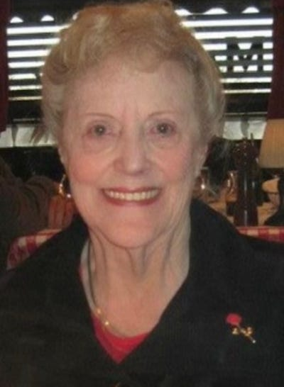

Carolyn D. Wacker
Bound Brook - Carolyn D. Wacker, 89, passed away at her residence on Sunday, May 8, 2022. Born in Newark to the late Anthony and Annmarie Antidormi, Carolyn lived in Highland Park and Piscataway before moving to Bound Brook.
She retired from Rutgers University where she was an Administrative Clerk for the Budget and Resource Department. Prior to, Carolyn worked in Newark for the Alcohol, Tobacco and Firearms Division. She also worked at Alan Silver and Associates as a Secretary and for the NJ Committee for Humanities.
Carolyn loved playing bingo and enjoyed the Game Show Network, where she could always be found watching Jeopardy every day at 7pm. She belonged to Our Lady of Mount Virgin Church in Middlesex as well as a member of the Altar Rosary Society. She enjoyed her time with the Middlesex Seniors and was a former secretary.
Carolyn loved spending time with her family, especially when it came to her children and grandchildren; there was never a school ceremony, dance recital or softball game she missed.
Predeceased by her siblings Ida Signorin and Rita Discenza, Carolyn leaves behind her daughter Suzanne Aquilone and her husband Rocco of Staten Island, NY and her son Joseph Wacker of Yardley, PA. She will be missed dearly by her three granddaughters; Julianna and Sabrina Aquilone and Jordyn Wacker. A special thank you to her caregiver Vernica Bass, who took great care of Carolyn 24/7.
Visitation will be held in Middlesex Funeral Home, 528 Bound Brook Road, Middlesex, NJ 08846 on Tuesday, May 10, 2022 from 4-8pm and on Wednesday, May 11, 2022 beginning 9:30am.
A 10:30am funeral mass will be held at Our Lady of Mount Virgin Church in Middlesex on Wednesday, May 11, 2022 with mausoleum entombment following at Resurrection Burial Park in Piscataway.
In lieu of flowers, memorial donations sent to the American Cancer Association (www.cancer.org) would be appreciated. Please visit Carolyn's interactive webpage at www.MiddlesexFuneralHome.com to send condolences to the family.

