ARTHUR KLINGHOFFER
Arthur Jay Klinghoffer, Professor Emeritus of Political Science at Rutgers University, Camden, passed away on December 24th, 2022. Son of the late Sidney and Libby Klinghoffer. Brother of Bette Fishbein. Husband of fifty-three years to Judith Apter Klinghoffer and father of Joella Clamen and father-in-law of Stewart Clamen.

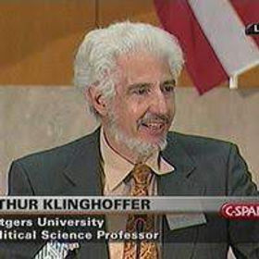
Arthur was the author of twelve academic books on a variety of subjects, among them human rights, genocide, Soviet Communism and the politics of oil and gold. Winner of Fulbright senior fellowships in Israel (1982), China (1992) and India (2003), he was also awarded a Nobel fellowship in Oslo in 1995. Arthur served as an adviser to several U.S. governmental agencies and was a frequent media commentator on current issues in the news.
Sharing a passion for travel with his wife Judith, Arthur traversed much of the globe, from the cliffs of Patagonia to the mountains of Tibet. In later life, he fell in love with the beaches, nature and cultural life of historic St. Augustine, Florida, where he and Judith bought a home on a canal.
In his last decade, Arthur struggled with Primary Progressive Aphasia, which gradually took away his ability to communicate verbally. Though challenges mounted, he approached them with his usual diligence and positivity. The persistence of his kind and playful spirit will be missed by all who knew him.

Relatives and friends are invited on Tuesday, December 27, 2022 beginning 1:00 pm at PLATT MEMORIAL CHAPELS, Inc. 2001 Berlin Road, Cherry Hill, NJ. The funeral service will begin promptly at 1:20 pm. The service was also live streamed on plattmemorial.com. Interment was at Crescent Memorial Park, Pennsauken, NJ. Shiva will be observed at the home of Judith Apter Klinghoffer immediately following the burial on Tuesday and continuing on Wednesday and Thursday afternoons.

Contributions in Arthur’s memory may be made to the National Aphasia Association: https://www.aphasia.org/donate/

