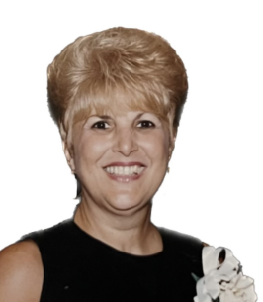

Virginia Normann
Virginia Normann, age 81, formerly of East Brunswick, peacefully passed away at her sister’s home on Tuesday, November 15, 2022, surrounded by her loving family. Born in Barranquilla, Colombia to the late Giuseppe and Elina Caputo, Virginia immigrated to the United States many years ago, first living in Queens and later settling in East Brunswick where she lived for over 43 years. Fourteen years ago, Virginia retired to Florida with her beloved husband, Joseph where they have lived ever since. Before her retirement, Mrs. Normann was employed for 25 years with Rutgers University as an administrative assistant in the Environmental Science Department at Cook College and worked in the Dean’s Office at the School of Communications and Library Studies at Rutgers College. Virginia was an avid dancer and possessed a warm and loving disposition. It was only natural for her to bring happiness to all who met her. Her positive outlook and constant smile always brightened the room. Virginia enjoyed playing cards with friends and family but loved nothing more than spending time with her sons and grandchildren. She will be missed by her beloved family and countless friends and all who knew her.
Virginia is predeceased by her parents, and by her siblings Nicholas Caputo and Adelaide Cameron. Surviving is her beloved husband of nearly 60 years Joseph Normann of The Villages, FL; her loving sons and their spouses Joseph and Minhee Normann of Somerset, Michael and Donna Normann of Cranford, and Matthew Normann of Clark; her dear grandchildren Katelyn, Matthew, Meghan, Michael, Taylor, and Allison; her sisters Marie and husband Rick Esposito of Parlin and Teresa Caputo of Parlin; daughter-in-law Teresa Normann of Clark; sister-in-law Rosalie Caputo of Lakewood; as well as many loving nieces and nephews. Aunt Virginia was a devoted Godmother to her nieces Elina Jean Christian of Ocala, Fl; and Melissa Garcia of Parlin.
A memorial mass will take place at 10 am on Friday, November 25 at St. Bernadette’s RC Church in the Parlin section of Old Bridge.
In lieu of flowers, memorial donations may be made in Virginia’s name to The National Shrine of St. Jude – Claretian Missionaries ( www.shrineofstjude.org ). Completed arrangements, directions, and letters of condolence to the family may be found by visiting www.spezzifuneralhome.com.

