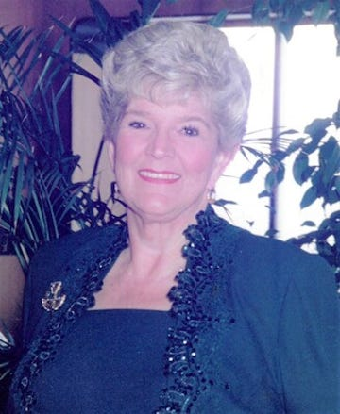

Obituary
Sheila Elaine Evans Yurochko Madigan, 82, of Ogunquit, ME, passed away peacefully October 28, 2022. She was born November 8, 1939 in Portland, ME to Joseph and Madeline (Morrow) Evans. Sheila moved to New Jersey with her parents for her last year of high school. She married her first husband, Michael Yurochko, in 1964 and together had a daughter, Kelli. They enjoyed square dancing as leaders of the “The Merry 8’s” and going on cruises. Sheila worked at Reichold Chemical, which is where she met Michael, and then went back to school to become a certified Medical Assistant before retiring as Senior Clerk Typist from Rutgers University. Sheila met her second husband, Dennis Madigan, in 1993. They enjoyed being members of the VFW and fulfilling a life-long dream of travelling to Ireland. Sheila was a lover of all animals. She especially loved dogs, cats, and red cardinals. She also enjoyed many genres of music and dancing. To meet Sheila was to love her. Sheila is survived by: her husband, Dennis Madigan; daughter, Kelli Yurochko; nieces, Deb (Jim) Maynard, Dee Dee Milardo, and Diane Evanns; dog, Misty; many cousins; and countless friends. Visitation will take place on Saturday, November 5, 2022, from 2:00 – 3:00 PM, followed by a funeral service at 3:00 PM, at Bibber Memorial Chapel, 111 Chapel Rd., Wells, ME 04090. A celebration of Sheila’s life will be held after the funeral at Kelli’s home. To share a memory or leave a message of condolence please visit Sheila’s Book of Memories Page at www.bibberfuneral.com. Arrangements are in the care of Bibber Memorial Chapel, 111 Chapel Rd. Wells, ME 04090.

