Obituaries

William H. Tucker
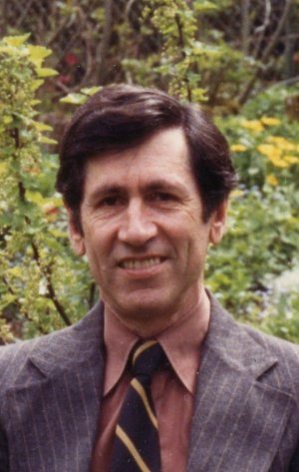

On May 31, 2022; Beloved husband of Monica Drozd; Tom Walrond, Aliena Walrond & Alex Walrond.
Bill was a Professor at Rutgers University- Camden for over 40 years. He will be truly missed by all who knew him.
Bill’s family and friends are invited to the Celebration of his Life on June 11th, 10 AM at the Rutgers University Camden Student Center. In lieu of flowers, memorial donations in honor of Bill may be made to Hopeworks Camden, 808 Market St., Camden, NJ 08102 (www.hopeworks.org) or Cathedral Kitchen, 1514 Federal St., Camden, NJ 08105 (www.cathedralkitchen.org)

