James Paul Begin

APRIL 19, 1938 – MARCH 4, 2023
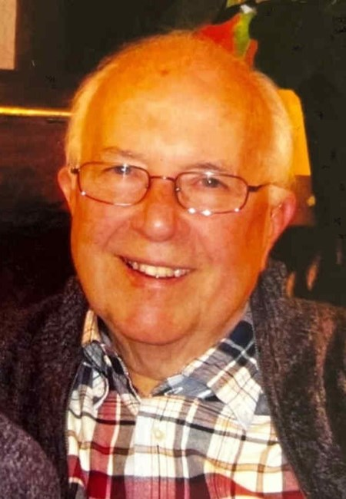

James Paul Begin was born on April 19, 1938 and died on March 4, 2023 at age 84.
Born in Greenville, Ohio, Jim was a resident of Princeton, NJ for 51 years. He joined Rutgers University’s Institute of Management and Labor Relations as an Assistant Professor in 1969 after receiving a PhD in Management from Purdue University. He served as Director of the Institute of Management and Labor Relations (later the School of Management & Labor Relations) at Rutgers from 1979 until 1990 and was named a Distinguished Professor in 1982. He retired from Rutgers in 1999. Jim was an active labor arbitrator and mediator throughout his career at Rutgers University, and was elected to the National Academy of Arbitrators. He also held appointments as a visiting scholar at the University of Warwick, UK and the Department of Economics at Princeton University.
Jim was a prolific author in the field of industrial relations and human resource management. Among his books are a text with Edwin Beal, The Practice of Collective Bargaining (Irwin, 1982, 1989), Strategic Employment Policy: An Organizational Systems Perspective (Prentice-Hall, 1991), and Dynamic Human Resources Systems: Cross National Comparisons (Walter de Gruyter, 1997). He was the founding President of the University Council of Industrial Relations and Human Resources Programs, an organization whose members are the heads of academic programs in the field of industrial relations and human resource management. At the time of his retirement he was the School’s Director of International Programs, and developed graduate programs in human resource management with organizations in China, Singapore, and Indonesia.
After retiring from Rutgers University, Jim enjoyed visiting battlefields, particularly those of the Civil War. He visited most eastern Civil War battlefields and supported organizations that worked to preserve those sites.
Jim was active in the Princeton community, having served on the Princeton Township Zoning Board for several terms and on the Board of the Princeton Adult School as well. His favorite volunteer activity, however, was as a coach for youth baseball in Princeton and a strong supporter of the baseball teams of John Witherspoon School and Princeton High School. His son, Robert, played baseball for the Princeton Public Schools and local youth baseball, and Jim provided informal coaching support and assistance for the coaches throughout Robert’s baseball career in Princeton.
Jim was called to active duty on the U.S. Navy in 1957, and served until 1959 on an aircraft carrier in the Pacific. He had a lifelong love for sailing and the sea.
In 2020, Jim and his wife, Barbara Lee, moved to Washington DC to be near their son, Robert and his wife, Rachel Snyderman. In addition to Barbara, Robert and Rachel, Jim leaves two grandchildren, Elias and Emmanuelle Begin, and a sister, Jean Capelli Lindsay of Los Alamos, NM.
Burial will be in Princeton Cemetery in Princeton, NJ at a later date. A celebration of life will be held locally in Washington, DC. In lieu of flowers, donations can be made to the American Battlefield Trust.

