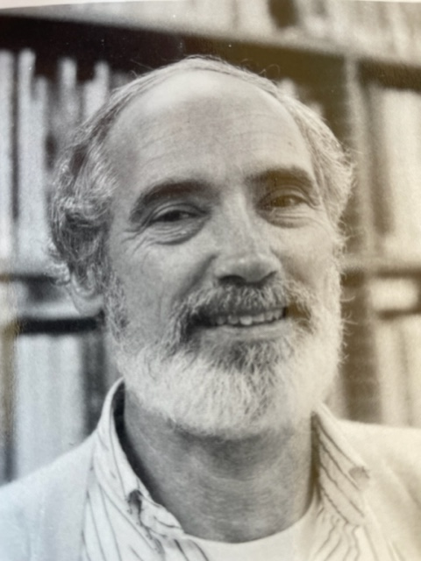

Donald T. Dickson, 82, passed away peacefully in his Florida home on January 18, 2022. Born in Downers Grove Illinois on March 18, 1939, Donald graduated from Carlton University and earned an Antarctic Service Medal from the National Science Foundation in recognition of valuable contributions to exploration and scientific achievement under the U.S. Antarctic Program. He earned a J.D. from the University of Chicago Law School, and a Ph.D. from the University of Michigan. In 1971, he became a Professor at the University of Rutgers, New Jersey. During his tenure, he published several books on law and social policy before retiring in 2007. In 2008, he was named Professor Emeritus, and continued to be a part time instructor and lecturer through 2019. He is survived by his sister, Barbara Dickson Stewart, and his son, David, and David’s wife and two children.

