Michael Steven Lancsak Sr.
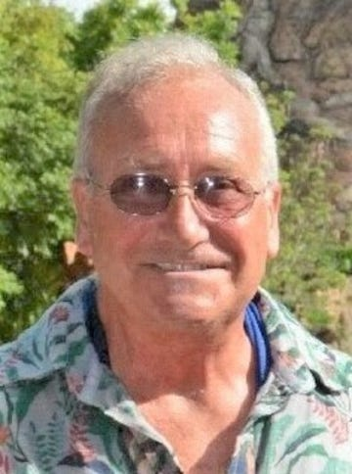

Michael Steven Lancsak Sr., 64, passed away suddenly on Sunday, June 26, 2022, at Robert Wood Johnson University Hospital in New Brunswick, New Jersey. Mr. Lancsak Sr. was born July 20, 1957, in New Brunswick, New Jersey. He was a lifelong resident of Somerset, NJ. Michael retired in 2020 after working at Rutgers University for 40 years as a coordinator at the President's House. Michael was predeceased by his father, John Lancsak II, and his brother, John III. He is survived by his loving wife of 40 years, Helen; his daughters, Melissa Fasolino and her husband Salvatore and Jennifer Shannon; his son Michael Lancsak Jr.; his mother, Ruth Lancsak; his brother, Robert Lancsak and his wife Marjorie; his two grandchildren, Elizabeth and Scarlett and many nieces, nephews, extended family, and friends. Visitation will be held from 4:00 to 7:00 P.M. on Friday, July 1st at the Gleason Funeral Home, 1360 Hamilton Street, Somerset, NJ.

