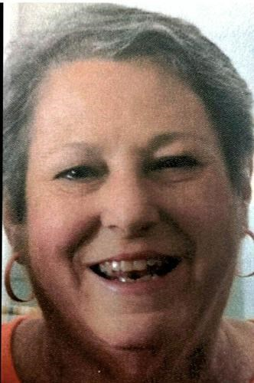
Maria V. Grace (nee Grayo), on May 16, 2022, of Laurel Springs; formerly of Bellmawr. Age 68.
Beloved wife of the late Joseph Grace, Sr. Devoted mother of Joseph Grace, Jr. (Stacey) and John Grace. Loving Nan of Joseph, Andrew, and Sarah. Dear sister of Ann Dooley (Woody). Also survived by many nieces and nephews. Daughter of the late John and Victoria Grayo.
Maria was a graduate of Paul VI High School and worked in the Bursar's Office at Rutgers University in Camden for over 20 years. She loved spending time with her lifelong friends "Girls Club" and most importantly her family. Maria also enjoyed cooking and reading.
There will be a visitation from 9:15am to 11:15am Saturday, June 18, 2022 at GARDNER FUNERAL HOME, RUNNEMEDE.
Memorial Mass 12 noon at Holy Child Parish, St. Teresa RC Church, Runnemede.
Interment is private at the request of the family.
In lieu of flowers, donations may be made in Maria's memory to American Kidney Fund, 11921 Rockville Pike, Suite 300, Rockville, MD 20852 (www.kidneyfund.org).
Published by Gardner Funeral Home, Runnemede on May 20, 2022.

