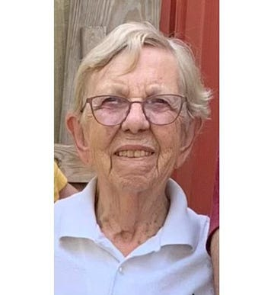
Janet E. Yocum, 93, of Lebanon, PA, died Sunday, July 30, 2023 at M. S. Hershey Medical Center.
Born in Mechanicsburg, PA on July 30, 1930, she was a daughter of the late Daniel W. and Hilda (Sholley) Yocum.
A 1948 graduate of Bethel High School, Janet continued her education and received a B.S from Catawba College and her Masters Degree from Indiana University.
She retired as an Assistant Dean of Student Affairs at Douglass College, a branch of Rutgers University. She also worked for Winthrop Laboratories.
Janet was a member of Church of the Good Shepherd, Lebanon and United Methodist Church at Milltown, NJ.
She enjoyed reading, puzzles, bible study, pickle ball, tennis, opera, traveling, and hanging out at the farm.
Janet is survived by sister-in-law, Carolyn H. Yocum, of NC; nephews, Darryl M. husband of Carol Brown,of Myerstown, Dennis A. husband of Jodie Yocum of NC; niece, The Rev. Maria wife of Joseph Carlson, of Lancaster; and several great nieces and nephews.
She was preceded in death by a sister, Anna E. Brown; brother, William R. Yocum; and a niece, Marluss P. Brown
Funeral services will be held Thursday, August 10 at 11 a.m. at Grose Funeral Home, Inc., 358 W. Washington Ave., Myerstown, PA. Visitation will begin at 10 a.m. Interment will follow at Mt. Hope Cemetery Myerstown, PA.
Memorial contributions may be made to: Quest, Inc. 704 Metro Drive Lebanon, PA 17042 or Catawba College, 2300 W Innes St., Salisbury, NC 28144 or catawba.edu.

