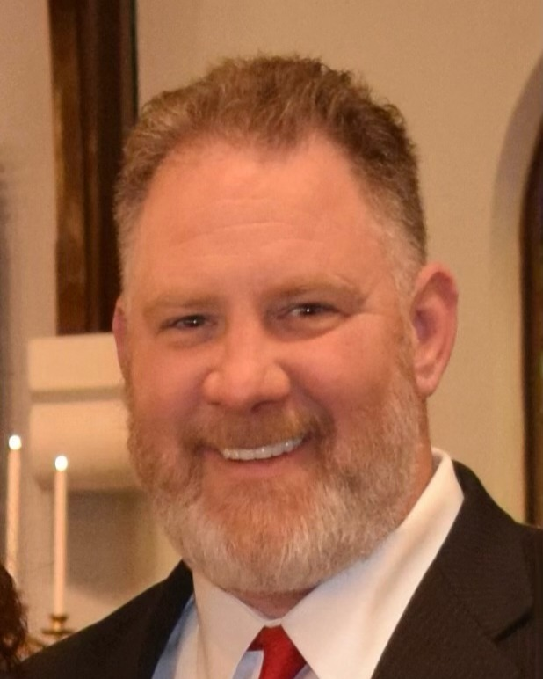
James C. West

April 26, 1970 — March 10, 2023

North Brunswick

James Christopher West passed away on March 10th, 2023, at the age of 52. He was a kind and caring person who was loved by all who met him. He touched many lives with his generosity and willingness to help others. James was born in Edison, New Jersey, to the parents of James Clyde West and Nancy Jane West. James grew up in Metuchen and graduated from Metuchen High School in 1988.
James was employed by Rutgers University at the Inn and Conference Center. He was recently awarded the 2022 Beloved Community Award for his dedication and passion when working alongside the members of the Adult Autism Services. Prior to his employment at Rutgers University, James was a member of the Local Carpenters Union located in Milltown, New Jersey.
James was one to live life to the fullest; he enjoyed spending time with family, friends, and his two dogs Dakota and Harper. He loved riding his Harley Davidson motorcycle, bowling with his friends, playing poker, and fishing. He was a treasurer hunter at heart who loved to spend his weekends at estate sales. James had a remarkable ability to see the beauty in things others did not.
James is survived by his beloved wife of 25 years, Kerri West, and his two daughters, Kayla, and Ashley West of North Brunswick, his brothers Bryan West (Jennifer) of Spotswood and Scott West of Metuchen. He is also survived by his nieces Julia, Carly, and Paige, and his nephews Connor, Matthew, Dylan, Ryan, and Luke.
James will be greatly missed by his family, friends, and all who knew him. He will be remembered for his friendliness and joy of life. James’ memory will live in the hearts of those who knew him and loved him, may he rest in peace.
On Tuesday, March 14th, there will be a visitation from 4:00-7:00 pm, at The Crabiel Home for Funerals 170 N. Main St.-at Riva Avenue, Milltown NJ 08850. You may sign the online guestbook at www.crabiel.com

