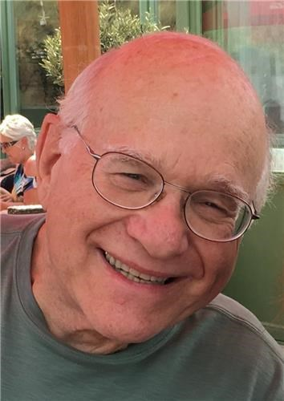
GARY GOLDEN OBITUARY
Dr. Gary Allen Golden peacefully passed away on April 30, 2022, at the age of 74.
Gary was born in New York City, to the late Sheldon and Rita (Turek) Golden, and was raised in Connecticut. Gary received his bachelor's degree from Marietta College in 1970. His fondest memory of that period was his attendance at the Woodstock Music and Art Fair between his junior and senior year. He received a master's degree from Ohio University in 1971, a second master's from the University of Kentucky in 1974, and a Ph.D. in Library and Information Science from the University of Illinois at Urbana-Champaign in 1983. He was a college librarian in the University of Illinois system for several years before joining the faculty of Rutgers University as the Director of the Paul Robeson Library at Rutgers-Camden. Gary held that position for 30 years until he retired in 2016.
Shortly after moving to New Jersey in 1986, Gary met the love of his life, Paula, whom he married in 1992. Gary became the stepfather to Paula's two children, Philip and David. Gary and Paula went on trips throughout Europe, the Middle East, and Africa; they regularly attended theater and concerts in Philadelphia and New York; and had frequent dinners out with friends. They also loved to visit U.S. national parks, building on Gary's love of nature and animals. Gary was an active member of Temple Sinai in Cinnaminson, New Jersey.
Gary is survived by his wife Paula (Greenberg) Golden, sons Philip Bigge (Patricia Bigge) and David Bigge (Kristy Tillman), grandchildren Kathryn, Samuel, and Nathaniel, brothers Richard Golden (Judy Klein-Golden) and David Golden (Steve Knapheide), and a large and loving extended family.
Relatives and friends are invited Monday, May 2, 2022 beginning 11:30 AM to Platt Memorial Chapel, 2001 Haddonfield-Berlin Rd, Cherry Hill, NJ 08003 where funeral services will begin promptly at 12:00 noon. Shiva will be held at the residence on May 2nd and May 3rd. Donations may be made to the Lewy Body Dementia Association (www.lbda.org), or to the charity of your choice.
Published by Platt Memorial Chapels, Inc. - Cherry Hill from May 3 to May 4, 2022.

