Gail Gleason Milgram
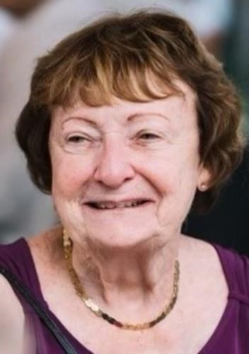
.
Rutgers Professor, Authority on Alcohol & Substance Abuse, "A Trailblazer in Her Field," Longtime East Brunswick Resident
Beloved Wife, Mother, Grandmother, and Friend GAIL GLEASON MILGRAM of East Brunswick NJ passed away peacefully with her family by her side on Saturday, July 8, 2023. Gail was predeceased by her beloved husband of 55 years, William (Bill) Milgram.
Born and raised in South Amboy, Gail was a Jersey girl through and through. She attended St. Mary's High School and Georgian Court University and then went on to receive her master's and doctorate in Education from Rutgers University. She called East Brunswick home for almost 54 years and cherished summertime at the Jersey Shore, first in Toms River and later in Long Beach Island, Bradley Beach, and Spring Lake.
Gail lived a life filled with service and purpose and, perhaps most of all, with love. She dedicated her life to the betterment of others and was a remarkable teacher, mentor, and friend. For over 40 years, Gail worked as a Professor and as the Director of Education and Training for the Center of Alcohol and Substance Use Studies at Rutgers University in New Brunswick. She also served for a time as an Adjunct Associate Professor at UMDNJ.
Gail was a trailblazer in her field and dedicated her entire career to helping others. She wrote and published 8 books on alcohol, substance use, and education and authored countless articles. She
also directed the Summer Schools of Alcohol Studies at Rutgers University, yearly courses that drew professionals from across the globe to learn about alcohol and substance use disorders. As
part of the Summer Schools, Gail led the Johnson & Johnson School Nurse Fellowship Program, which trained hundreds of school nurses from across the United States. Gail also had the privilege to be part of numerous international delegations, and she and Bill loved combining her work trips with vacations across the world. Gail gave generously of her time and served on many boards, including Freedom House, BACCHUS, SADD, and Alcohol Research Documentation, Inc. Among Gail's many honors and achievements, she was an editor of Alcohol Treatment Quarterly and the Journal of Studies on Alcohol and Drugs. Her contributions to the field were honored through numerous awards, including a Rutgers University Faculty Merit Award and the Middlesex County Alcohol Association Distinguished Service Award.
Gail previously served as President of the Georgian Court University Alumni Association and was a member of the Court of Honor.
Anchored by her Catholic faith and the values of hard-work and devotion, Gail was always thinking about what she could do for others. She had many hobbies and loved attending Broadway shows, going out for dinner with Bill and their friends, hosting her children and grandchildren in East Brunswick, traveling the world, and grabbing lunch with her friends. Gail cherished her Irish heritage and celebrated her beloved St. Patrick's Day each year with a trip to the South Amboy St. Patrick's Day Parade.
Above all, Gail's greatest pride and joy was her family, and especially her grandchildren. Her three grandchildren brought countless hours of joy to her, and she went out of her way to do special things for each of them. She and Bill organized a yearly summer camp for the kids, Camp MoPo (MomMom and PopPop), which included time at the Jersey Shore, trips to Delicious Orchards, and nightly barbecues.
Gail was a parishioner of St. Bartholomew Roman Catholic Church in East Brunswick.
Surviving are her two daughters, Lynn Mayer and her husband, Guy, Anne Milgram and her husband, Manuel, and her three grandchildren.
Family and friends may visit on Friday, July 14, 2023, from 3:00 to 7:00 pm, at The BRUNSWICK MEMORIAL HOME, 454 Cranbury Road, East Brunswick.
Funeral services will be held on Saturday, July 15th, at the funeral home at 9:15 am, with a 10:00 am Mass of Christian Burial at St. Bartholomew Roman Catholic Church, East Brunswick, followed by interment at St, Mary Cemetery, South Amboy.

