Frances Koppell

FEBRUARY 13, 1959 – JUNE 30, 2023
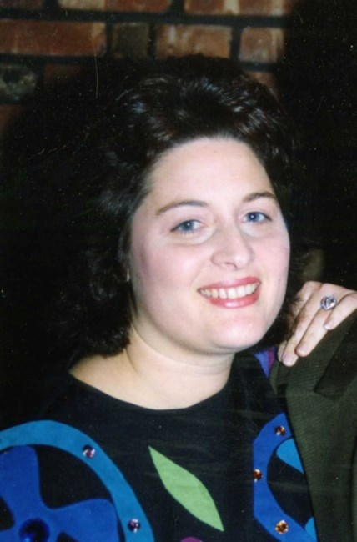

Frances Koppell, age 64, passed away peacefully in her home on June 30, 2023 after a courageous and inspiring two-year battle with pancreatic cancer.
Fran was born in 1959 and spent her formative years in East Atlantic Beach, Long Island, where she grew up with her loving parents, the late Harold and Isabel Kaskel, and her siblings Michael and Jeanne Kaskel. It was in this vibrant beach community that Frances developed a profound love for the ocean.
In 1977, Fran met her soulmate, Michael, at the University of Buffalo, and their connection was instantaneous. They were married on June 28, 1981 on Long Island. Fran and Mike settled in New York City, where Fran began her successful career in marketing. Later, she chose to become a devoted stay-at-home mom when they settled in the suburbs of East Brunswick, NJ, to start their family. Fran embraced the role of motherhood with boundless love, always finding opportunities to spoil her three children.
As her children grew older, Fran returned to work as a Program Coordinator for Rutgers University. This role allowed her to maintain a close connection with her children, as all three of them pursued higher education at the same university. She not only opened her home to her children's friends but also warmly welcomed the students in her program, exemplifying her innate desire to make everyone feel at home. For Fran, family and togetherness were cherished above all else.
Fran is survived by her loving husband of 42 years, Michael, her children Harrison and his wife Leanne, Daniel and his wife Moira, and Valerie and her husband Michael, as well as her beloved grandchildren Emily, Madelyn, Kira, Colin, and Rory Koppell, and Eliana and Gabriel Lenz.
Services:
A memorial service to celebrate Fran’s life will be held on Thursday, July 13th at 2pm at the Regency Clubhouse, located at 61 Country Club Drive, Monroe Twp., NJ 08831. There will be a luncheon to follow. Please mention to security and the front desk that you are there for a private event. This community held a special place in Fran’s heart during the last years of her life.
There will also be Shiva the evening of July 13th at 6pm hosted by Michael Koppell in their home, 28 Crenshaw Court, Monroe Twp., NJ 08831.
In honor of Fran’s memory, the family kindly requests that memorial contributions be made to PanCAN (Pancreatic Cancer Action Network) for pancreatic cancer research. Donations can be made at https://secure.pancan.org/site/Donation2?df_id=2681&mfc_pref=T&2681.donation=form1

