Dr. Kevin Charles Pineda DO
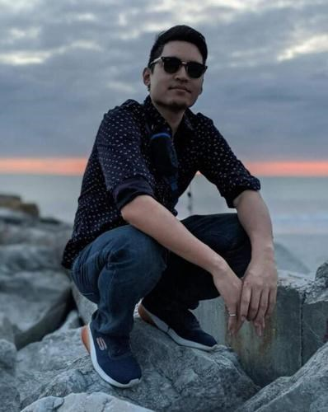
Dr. Kevin Charles Pineda, DO was 29 years old when he passed away suddenly Wednesday, November 09, 2022. Born in New York City, Kevin was a resident of New Milford for most of his life. He was a graduate of the David Owens Middle School, New Milford. Kevin would later attend Bergen Technical High School, Teterboro, New Jersey. He would go on to graduate Cum Laude in Bio-Medical Engineering at the College of New Jersey in 2014. After completing his undergraduate studies at The College of New Jersey, Kevin would once again graduate Cum Laude at the Touro College of Osteopathic Medicine in Middletown, New York in 2019. After medical school, Dr. Kevin completed his first-year residency at Morristown Medical Center. Dr. Kevin was currently serving as a fourth-year Physician Resident at the Kessler Institute for Rehabilitation, West Orange.
He is survived by his loving parents Leonilo Pineda and Grace, his beloved wife Dr. Johana Zambrano, DO, his sister Dana-Kristie Pineda, brothers John Paul Pineda, Jeremy Nel Pineda and Joseph Emman Pineda as well as many relatives, friends, and colleagues.
Kevin will be always remembered as a kind soul who took to heart the concern of those around him, providing a constant pillar of support to many. An amiable person, he was able to bridge and connect many friendships; with his easy-going nature, he was able to break down walls, creating a sense of comfort and sanctuary for others.
Many people would know him for his exuberant personality and humorous spirit. Empathy and compassion came naturally to him, and his soft nature elevated his already brilliant character and dedication to his practice.
He put unmatched effort in all parts of his life, from his relationship with his wife Johana, his dad Leonilo, his mom Grace, sister Dana, his friends, to medicine, and competitive (but always friendly) video games with his friends.
Kevin refused to compromise for anything less than his full potential from himself, or others. Kevin saw the potential we all have and had high standards for his friends and families which inspired us to become better people with him. It is Kevin's unrelenting spirit, strong will, and deep compassion that inspired us to follow him and reach our potential, and it is his memory that will continue inspiring us to keep moving forward. There would be no better way to honor him.
Family and friends are invited to visiting hours at the Boulevard Funeral Home and Cremation Service, 1151 River Road, New Milford, NJ on Monday from 3 pm to 5 pm and 7 pm to 9pm. The following morning, Tuesday, a Funeral Mass will be celebrated in his memory at 10 am in the Church of the Ascension, New Milford. Following the Funeral Mass Dr. Kevin will be laid to rest at Garden of Memories Cemetery, Soldier Hill Road, Township of Washington, NJ.
For those who cannot attend the visiting hours, a live stream will be available on Monday from 3 pm to 5 pm and 7 pm to 9 pm by visiting www.boulevardfuneralhome.com

