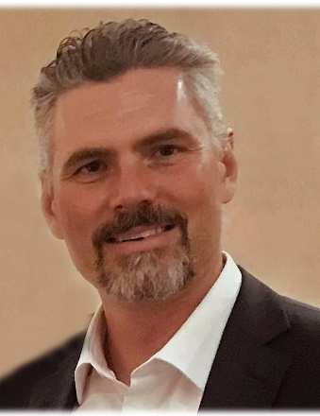
Dr. Franklin L. Moon II, 46, passed away on May 27, 2023 surrounded by his loving family.
Frank was born on July 14, 1976, the 2nd of 5 children, to Joseph and Helen Moon in Schenectady, NY. Frank graduated from Niskayuna High school in 1994. He attended the University of Delaware, receiving both his Bachelor's (1998) and Masters (2000) in Civil Engineering. There, Frank discovered a passion for research and a gift for teaching. He went on to obtain his PhD from Georgia Tech University, focusing his research on strengthening masonry structures to withstand earthquake forces. Frank became a professor of civil Engineering first at Drexel University, and then Rutgers University. He also started a successful consulting company along the way called Intelligent Infrastructure Systems.

Frank was known for his humor, good nature and his faith . He was a fantastic athlete; running cross-country, playing basketball, and high jumping for Niskayuna high school where he held the record for many years. He loved playing the piano, drawing and painting- including a hilariously enormous ping pong table with a portrait of Forrest Gump. He once made a special piece of art and had it delivered to one of his favorite musicians, Billy Joel. Most importantly Frank was a person of faith and that was apparent in all areas of his life. It was important for him to find understanding, and grow his faith, and he worked to encounter God in his life,

Frank met the love of his life, Erica Comley one summer in Saratoga. The two were inseparable from the beginning and their love was a fairytale. They were married in Schenectady, NY in 2002. They welcomed 3 beautiful girls, Julia, Emma and Gabrielle. Frank was a loving, patient, and adoring husband and father. He loved to boast about ALL of his girls; always being proud to call himself a “Girl Dad”, and they in turn loved their father. Frank and his “Eriky” made many memories at the Jersey shore, playing golf entertaining friends, visiting family, incredible birthday celebrations, and of course cheering on his 3 girls at all of their many sporting events.

In his professional life, Frank became a widely respected bridge expert who was called to testify before state and federal legislative committees. He received many awards and traveled around the world with his work. His research resulted in a unique system (termed THMPER ™), which received the ASCE Pankow Award for Innovation in 2017. Frank was always passionate about his many research projects and his PhD students. Frank had a talent for explaining the most complicated engineering science so that anyone could really understand it- and he loved it! Over the years he had numerous PhD students which he often spoke of like a loving father and was so proud to see what they became.

To know Frank was to know his love of conversation. Frank was a beautiful communicator- both talking and listening. He loved to solve problems and he loved to create a real connection with the people in his life. Frank was a builder of bridges; both literally and figuratively. Both Erica and Frank built an amazingly supportive group of Friends that have been a source of strength for the whole family during these last few years.

His diagnosis of Glioblastoma in June 2020 was a terrible tragedy to Frank, his loving family, and all that knew and loved him. He fought that terrible disease bravely, and humbly; even when the disease destroyed his ability to communicate he found other ways of showing his love.

Frank will always be remembered by his Wife, Erica Comley Moon, Daughters Julia Slater Moon (17), Emma Shannon Moon (15), Gabrielle Valentino Moon (12). His Parents, Joseph and Helen Moon. His siblings William Moon and wife Stefanie, Mary Manzo and husband Stephen Manzo, Catherine Weiss and husband Andrew Weiss, Michelle Porter and Husband Kevin Porter, and Erica’s parents, Paul and Lou Carol Comley, Erica’s sister Shannon and husband Vinay Sood, as well as Numerous Aunts and Uncles, Cousins and his Nieces and Nephews whom he loved.

Relatives and friends are invited to his visitation on Wednesday May 31st from 5-8 PM at the St. Joan of Arc Catholic Church, 100 Willow Bend Rd., Marlton, NJ. Mass of Christian burial will celebrated 1:30 PM on Thursday June 1st at the St. Joan of Arc Church. Interment will be private.

