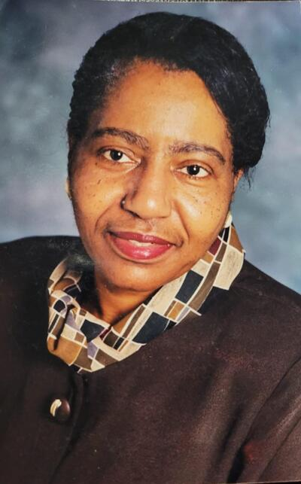

Dr. Francine Essien

March 7, 1943 - March 4, 2022

DR. FRANCINE'S OBITUARY
Francine Bowden was born on March 7, 1943 in Augusta Georgia to the late Mary Jane Edwards and Earnest Bowden. She was the third child of four children who are now deceased. She grew up in Philadelphia, Pennsylvania, attending James Rhoads Elementary School, Sulzberger Junior High and Philadelphia High School for Girls. Francine was an avid reader and outstanding student. She enjoyed singing, playing board games, cards, jump rope, jacks, taking long walks and going to the movies.
She always had a deep love for science, even from her very early years, which you will hear more about in her own words, referred to as “My Story”. This love of science and learning propelled her life into the kind of wife, mother, educator, role model and mentor that she became. Her passion for science stayed with her throughout high school, college, graduate and postgraduate studies. That flame continued to burn, even until the day she departed from us.
Francine met and fell in love with the late Wilcox Essien at Temple University who was a native of Nigeria. She gained two daughters Ekaette and Ekanem when she married Wilcox. The marriage produced her only son, Ikanke Essien. Francine was loved and adored by all, always going above and beyond to extend herself to friends, family, perfect strangers and the wider community. Her family grew when she welcomed her deceased sister’s children, Sheilla and Lavern Bowden into her home and raised them as her own. Her doors were always open to her friends and family.
Francine was loving and compassionate, with a heart of gold. As she would often reflect on her own struggles growing up in Philadelphia, she was determined to give her best to her friends, family and the community, especially to young women and minority groups, which she felt were underrepresented in the larger spheres of life. She always wanted to help and make life better for those who crossed her path, especially her students at Rutgers University. She was a matriarch and dynamic role model in her community of Somerset, New Brunswick, New Jersey, where she spent a great portion of her adult life. Francine loved life and loved people and would enjoy numerous trips around the country and around the world with her friends.
Being a brilliant scientist did not diminish Francine’s Christian faith or her love for God. She surrendered her life to Him at an early age, attending White Rock Baptist Church. Francine would always give the credit to God for all that she had accomplished. Francine’s life was and will continue to be an inspiration to many, as she was a lifelong learner and educator. Even during her illness, she never stopped reading medical and scientific journals.
Dr. Francine B. Essien’s professional and academic life spanned decades. She received her B.A. degree from Temple University, receiving the second highest average in Liberal Arts and her Ph.D. in Genetics from the Albert Einstein College of Medicine (Yeshiva University). She completed post-doctoral study at the Univ. of Connecticut in Storrs. She then joined the faculty of Rutgers University (New Brunswick) in the Dept. of Biological Sciences, teaching courses at the undergraduate and graduate levels, such as comparative anatomy, developmental biology and genetics in 1968.
She established a research program, studying the effects of mutations which she discovered in mice, such as ones affecting skeletal muscle differentiation, cardiac development, and neural tube formation. Graduate students and undergraduates assisted her in conducting her research and published with her. With regard to the sciences, health professions, engineering, and other areas of technology, Dr. Essien had a long standing concern about the under-representation of minorities and individuals from backgrounds of economic disadvantage. She collaborated with committed colleagues at Rutgers and other institutions in developing programs to enhance greater participation of these groups in such fields. These cooperative efforts led to the establishment of the Office of Minority Undergraduate Science Programs, which offered the Biomedical Careers Program and the Success in the Sciences (S.I.S) and Access-Med programs.
Dr. Essien served as a Fulbright Professor in Nigeria, teaching at the University of Port Harcourt for one year. She has made presentations on her research and educational initiatives at national and international meetings. She is the recipient of numerous awards and honors from students, academic institutions, civic associations, churches, and scientific organizations. The Carnegie Foundation named her the 1994-95 U.S. Professor of the Year for Research and Doctoral Universities.
In 2007, and after many years of challenges with her health Dr.Francine moved to Atlanta , Georgia. It wasn't easy for her as her health challenges continued. However she spent her final years serving others, her church, the community, volunteering and contributing to various charities until she was not able to do so.
Today, we do not mourn as those without hope, but we celebrate her life!

Dr. Francine Essien was a wonderful mother, grandmother, sister, aunt, friend and mentor. She will be truly missed, but we know that there's a place up in heaven for her with her Heavenly Father She will be forever remembered by her son, Ikanke Essien, her daughter-in -law, Traceyann Essien, daughters Ekaette Pinney, Ekanem Ikpo, sister -in law, Joyce Essien, dear friends, Jeannette Manis, Conchita Showell, Pauline Jones, Ruth Manis, Mary Ann Lucas, Rosemond Wilmer, grand children, Ikanke Palmer, Anthony Rhodes, Jasmine Essien, David Essien, Nieces, Ronke Essien, Sheila Bowden, Lavern Bowden, Nephews, Ekan Essien and his wife Julia Essien, Mike and Tony Bowden, staff and students at Rutgers University, members of the Ebenezer Baptist Church in Atlanta, friends and neighbors at Museum Tower, 285 Centennial Olympic Park Dr. NW. in Atlanta, Georgia and a whole host of other relatives and friends.

