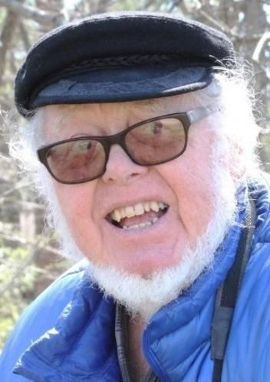
Charlie F. Leck, 78, died Tuesday, February 28, 2023 at Parker at Monroe of Monroe Township, NJ.
Born and raised in Princeton, he resided in Kendall Park before moving to Monroe Township. Charles received his undergraduate degree, magna cum laude, from Muhlenberg College, Allentown, PA and his PhD in Vertebrate Zoology from Cornell University, Ithaca, NY.
Charlie taught undergraduate courses in ornithology and ecology and graduate courses in natural history and animal behavior at Rutgers University, New Brunswick, NJ for 30 years, before retiring in 2000.
At Rutgers, he supervised many student research projects and served as Director of the Graduate Ecology Program, for 6 years. He was author of numerous articles as well as 2 books, The Birds of New Jersey: Their Habits and Habitat and The Status and Distribution of New Jersey's Birds (Rutgers University Press) and coauthor of 'Checklist of the Birds of the U.S. Virgin Islands' with P. Norton, Antilles Press.
His research interests were varied and included: landscape ecology; long term population trends in breeding bird surveys (West Indies and NJ) and reasons of expansions; and biological surveys of the Abbott Marshlands (Mercer Co..NJ. He was an elected member of the American Omithologists' Union.
Son of the late George and Carrie (Schaal) Leck, Charlie is survived by his wife of 49 years, Mary (Allessio) Leck, a brother George Leck (Barbara) of Tucker, Georgia, sister-in-law Rosemary Morton of Hinsdale, MA, brother-in-law, Michael Allessio, of Pittsfield, MA, and seven nieces and nephews.
Charlie will be remembered for his sense of humor and wit, his knowledge and love of birds, and his contagious enthusiasm and avid support of the natural world, all of which he shared generously.
He, with his wife, was a recipient of a Governors Environmental Excellence Award for Stewardship, acknowledging a long-term commitment to preserving and protecting the Abbott Marshlands, an urban wetland near Trenton, NJ. He was a frequent leader of field trips and provided inventories of Abbott Marsh animals, including birds, reptiles and amphibians, and mammals. He was featured in the award winning NJN documentary 'Turning the Tide' about NJ wetlands.
A memorial celebration will be held in June. In lieu of flowers, memorial contributions can be made to
The Friends for the Abbott Marshlands, New Jersey Audubon Society, or Washington Crossing Audubon.
Arrangements are private under the direction of the M.J. Murphy Funeral Home, Monmouth Junction.

