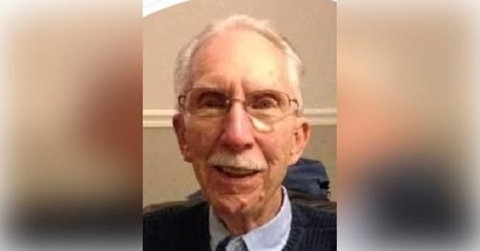

CHARLES HASHAGEN OBITUARY
Hashagen, Charles R., age 94, of Vero Beach, FL, on Tuesday, April 18, 2023. Born in Brooklyn in 1928, Charles moved to Paterson in 1931 and then to Hawthorne in 1985, Totowa in 2016, and then Vero Beach, FL in 2020. He worked in the family business, ("Hashagen's Confectionary") from 1947 to 1961. He was employed by Federal Electric Corp as a Technical Recruiter for the Early Warning System (Dew Line) from 1962 to 1968; and as a part time Instructor for Rutgers Extension Division and a part time counselor for Rutgers University Extension Division and for University College. He received his Master's Degree in Business Adminstration and joined Rutgers University in 1968 as an Assistant Director of the Paterson Division of University College and as director of the Newark Division in 1975. He became the Registrar of the Newark Campus of Rutgers University in 1977 and retired in 1991.
He served in the Naval Reserve from 1947-1952 and in the U.S. Army from November 1952 through 1954 during the Korean War. He was honorably discharged with the rank of Staff Sgt.

He was a member of the Messiah Lutheran Church in Oakland; a member of the Gatun Lodge A.F. & A.M., Balboa, Republic of Panama, Genesis Lodge #88, F. & A.M., Pompton Lakes, NJ; Iowa Research Lodge, Dubuque Iowa, NJ Lodge of Research No. 1786, honorary member of the De Molay Legion of Honor, the Northern Valley of Scottish Rite and the North Jersey Past Masters Association. He also served on 10 Grand Lodge Staffs between 1997 and 2006.
Charles was the beloved husband of the late Lois (nee: Parkin) Hashagen (1996). Loving father of Craig A. Hashagen of Dubuque, IA, and Gail Rosso and her husband Thomas of Vero Beach, FL. Dear grandfather of Dana Ziegler and her husband Jesse Rosenbaum, Jennifer Hashagen, Gina Clark and her husband Shawn and Christopher Rosso and his wife Ashley. Dearest great-grandfather of Logan, Reilly, Keira and Brielle. Charles was predeceased by his brother John Hashagen.
Funeral will depart at 9:15am on Wednesday, April 26, 2023 from the Browning-Forshay Funeral Home, 557 Lafayette Ave., Hawthorne, for a 10:00am funeral service at Messiah Lutheran Church, 228 Ramapo Valley Road, Oakland, NJ 07436. Interment will follow at George Washington Memorial Park in Paramus. Friends may visit with the family at the funeral home on Tuesday from 2-4 & 7-9pm.
In lieu of flowers, memorial donations may be made to the Masonic Charity Foundation of New Jersey, 902 Jacksonville Road, Burlington, NJ 08016, Messiah Lutheran Church, 228 Ramapo Valley Road, Oakland, NJ 07436, Memorial Sloan Kettering Cancer Center, P.O. Box 5028 Hagerstown, MD 21741-5028, or the American Heart Association, PO Box 840692, Dallas, TX 75284-0692.

