Carole Cecile Walker
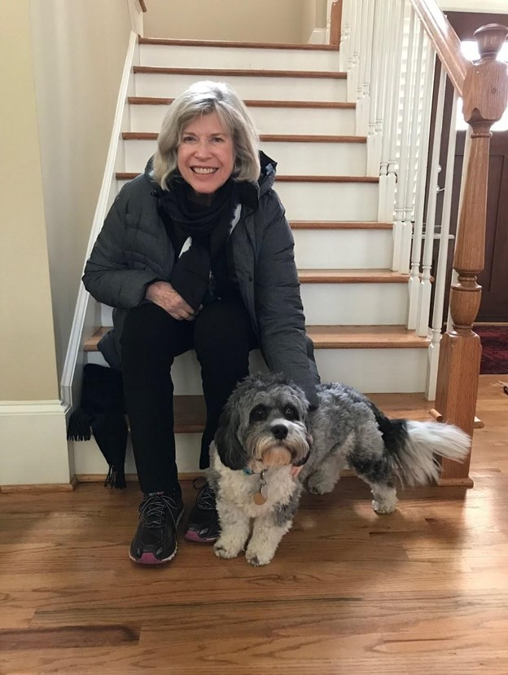

November 4, 1940 ~ August 29, 2023
Carole Cecile Walker, an avid learner, nature-lover, Francophile, relentless tweaker of recipes, devoted friend, and loving mother, mother-in-law, and grandmother, died peacefully at her home in Decatur on August 29, following an illness she faced with courage, grit, grace, and perseverance.
Carole was born in Memphis, Tennessee on November 4, 1940, the daughter of Joseph Walker and Eunice Arnaud. She spent her early years in Marianna, Arkansas; Havana, Cuba; West Palm Beach, Florida; College Station, Texas; and finally, Alexandria, Virginia, where she graduated from Francis C. Hammond High School. Naturally thoughtful and intellectually curious, her frequent childhood moves only cemented Carole’s interest in the world, and made her especially gifted at connecting with people, listening to their stories and creating relationships that transcended culture, age, and social status. She believed that people are amazing, and that they help make the world a kinder place.
After high school, she attended Smith College in Northampton, Massachusetts where she
majored in American Studies. After graduating from Smith in 1962, Carole volunteered for the newly-created U.S. Peace Corps as part of the second group of volunteers to join its first-ever class, and served in the West African nation of Guinea where she taught English to the French-speaking students. She traveled extensively in West Africa and Europe following her Peace Corps tour.
Upon her return to the United States, she worked in the Office of Congressional Relations at the Peace Corps and was influential in building support for the Peace Corps in Congress. In 1967, she moved to Highland Park, New Jersey with her former spouse, Ross Baker, and raised two daughters, Susannah and Sarah (Sally). Her daughters fondly remember lively and laughter-filled dinner parties in their home, watching the sun set and picking wildflowers together in Maine, taking nature walks in the woods, reading “The Wind in the Willows” together aloud, making drippy sand castles and combing the beach for seashells, playing gin rummy on her bed before going to sleep at night, watching her draw hearts and secret messages with a knife in the peanut butter sandwiches she sent with them to school, and making frozen lemonade popsicles on hot summer days.
Once her daughters were in school, Carole returned to school, herself, earning a Master of City and Regional Planning Degree from Rutgers University. Carole joined the Center for Urban Policy Research at Rutgers University where she co-authored a number of influential studies on housing and urban design, including “The Subdivision and Site Plan Handbook,” still considered a definitive resource on the subject for government officials, planners, developers, and attorneys.
After retiring, she relocated to the Atlanta area, where she participated in a French language study group, volunteered at the Carter Center, and was active in her neighborhood association. Her academic background, interest in landscape, and eye for design made her a natural gardener, and she graced every place she lived with lovely trees and flowers. She spoke often of the importance of sidewalks, and touted the virtues of tree canopies over neighborhood streets.
Carole was an accomplished cook with a repertoire of popular dishes – including Grammy’s spaghetti, a Christmas chocolate roll with crème fraîche filling, flan, her homemade olive oil and balsamic vinegar salad dressing with mashed garlic and salt, and salade Niçoise – followed by a dinner table discussion about how she could tweak the recipe to improve the results. She was a meticulous researcher with attention to the tiniest details, skills that she used translating historic family documents and letters from French into English.
Carole maintained lifelong friendships and missed no opportunity to connect with someone new–whether it was a neighbor or someone who rear-ended her in traffic. She felt enormous gratitude for the support and love of her sons-in-law, and embraced them fully, without reservation. She delighted in her grandchildren, encouraging them to learn what they love to do, explore and work hard, travel and read, be open to new experiences, take responsibility, and celebrate their successes. And nothing made her prouder than her two daughters.
A non-comprehensive list of her other interests and enjoyments includes: discussing current events, reading, history, making sure her daughters, sons-in-law, and grandchildren had at least one wrapped gift to open on their respective birthdays, voting, road trips (especially through the Blue Ridge Mountains), genealogy, French (she always claimed that she was not fluent, but anyone who heard her speak would disagree), sunrises, Indian food (particularly saag paneer and raita), swimming laps at the pool, beachcombing, “Finding Your Roots” on PBS, MSNBC (Morning Joe and Deadline: White House were particular favorites), Your DeKalb Farmers Market, C-SPAN, antiques, Jacques Pepin, not-too-expensive Côtes du Rhones, and Epoisses, a French cheese.
She is survived by her two loving daughters, Susannah (Robert) Khayat of Decatur, Georgia, and Sarah (Mike Kelly) Baker of Alexandria, Virginia, and four grandchildren: Margaret (Molly) Khayat, Benjamin (Ben) Khayat, Elizabeth Khayat, and Maeve Kelly, and by her sister, Diane Walker Smith, of Atlanta. She also leaves behind her beloved dog, Bailey, and many dear friends who will always remember her keen intellect, refined taste, generous spirit, curiosity and lifelong interest in learning, and devotion to family and friends.
A Memorial Service will be held on Saturday, September 23, 2023 at 4:00 pm at The Chapel on Sycamore, 318 Sycamore Street, Decatur, GA, 30030. A hyperlink to view the service live will be available to those who are unable to attend in person. In lieu of flowers, her family requests that donations be made to Doctors Without Borders or the Atlanta Botanical Garden.

