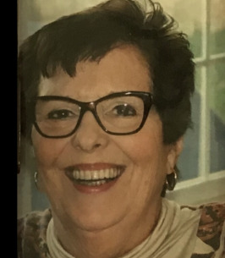
Our extraordinary mother Carol Feinberg passed away peacefully in her home from non-Hodgkin’s lymphoma on January 24, 2022. She will be deeply missed by those who loved her. We take solace in knowing that the joyful spirit, radiant beauty, kindness and thoughtfulness she shared throughout her life will always shine through us.
Carol’s wisdom and compassion overflowed throughout her life through in the many roles that she filled – daughter, mother, grandmother, loyal friend, confidant, and colleague. During her illness Carol never stopped appreciating the abundance of beauty and love in her life and continued to bring her optimistic outlook, grace and beautiful smile to everyone she encountered.
Carol was born in Milan, Italy in 1940 during WWII. After her father passed in 1942, Carol and her mother moved to Bordighera, Italy which was under German occupation, and then relocated to New York City in 1948. She graduated in 1957 from Howard Seminary in West Bridgewater, MA and later attended NYU until she met and married her beloved husband Richard in 1960. In 1961 they moved to Somerset and raised their three daughters.
When her children were teenagers, Carol began a career in the Italian Department at Rutgers University. She immediately became the heart of the department. Her vibrant personality and vivacious spirit touched the lives of everyone she met. She was honored to be part of the team that published the Italian Quarterly, a prestigious literary journal. Carol remained at Rutgers, enjoying her wonderful relationship with the students and faculty for over 25 years before her retirement in 2009.
Carol loved traveling with her family in the U.S. and many countries abroad. She had a passion for foreign film and theatre and she also enjoyed playing cards and Scrabble with her dear friends, children and grandchildren. She was a unique and remarkable person, dearly loved by many and cherished by her children and grandchildren. Though she is absent, her spirit remains with us. We are heartened by memories of her brilliance, passion for life, and kindness she shared with so many.
Most of all she loved her family and instilled in her daughters and grandchildren strong values that have served them well. She will be deeply missed and forever in our hearts.
Predeceased by her beloved husband Richard, Carol is survived by her daughters, April Feinberg, Susan Hope, Kim DiBuono, her son-in-law Allen DiBuono and her grandchildren Jake and Jeri DiBuono.

