May 5, 1941 - April 1, 2023
Recommend Bruce's obituary to your friends.
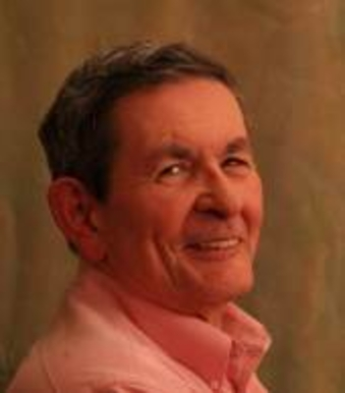
Bruce W. Howard

HOWARD, Bruce W., age 81, of Elmwood Park, and formerly of Englewood, passed away on Saturday, April 1, 2023. Bruce was born in Norfolk, VA to Robert and Anne (Leish) Howard. He has been a resident of Elmwood Park for 44 years. After graduating from St. Cecilia High School in Englewood, Bruce went on the receive his bachelor’s in business management at Bloomfield College. He was an administrator in the Student Service Department at Rutgers School of Nursing. Bruce was an active member of St. Anne’s RC Church in Fairlawn. He was a eucharistic minister, and a team leader for the eucharistic ministry. He also was active in, and the former president of the Englewood Lions Club.
Bruce is survived by his loving wife of 51 years, Margaret (Nestor) Howard. Beloved father of Mark Howard of Clifton, and Shannon Reed and her husband Jason of Pasadena, CA. Adoring grandfather to Penny Reed. He is also survived by his siblings, Peggy Wood, Patricia Howard, and Adrian Howard. He was predeceased by his brother Noel Howard. Bruce was a kind, loving, and humble man who just by his presence made the world a better place. Bruce will be greatly missed by all those who knew and loved him.
A Memorial Mass will be held on Friday, April 14, 2023, at 11 AM at St. Anne’s RC Church, 15-05 St. Anne Street, Fairlawn, NJ. A private cremation was held.
In lieu of flowers, donations may be made in Bruce’s memory to St. Anne’s RC Church, 15-05 St. Anne Street, Fair Lawn, NJ 07410, or visit www.stannefairlawnnj.org.

