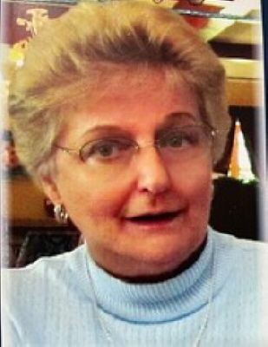
BROUGHT TO YOU BY CARMEN F. SPEZZI FUNERAL HOME
Barbara Molnar
February 17, 1945 – June 11, 2022

Barbara Molnar, age 77, passed away with her loving husband Frank and their beloved dog Maxie at her side on Saturday, June 11, 2022, at her home in South River, NJ. Barbara was born in South River where she met her husband of over 52 years, Frank Molnar. She retired from Rutgers University in 2002, after working at the University for decades. Barbara was a communicant of St Mary of Ostrabrama R.C. Church and was member of the St Mary’s Seniors as well as a member of the American Legion Post 214 Ladies Auxiliary. Barbara enjoyed traveling, reading, and spending her summers aboard their boat entertaining friends and family as Frank’s first mate. She was a loving and devoted wife and will be missed dearly by her friends and family.
She is predeceased by her parents, Louis and Blanche Lukowski, her brother Thomas Lukowski and nephew Thomas Lukowski Jr. Surviving are her husband Frank Molnar, her nieces and nephews, Thomas and Christine Molnar, Karey Molnar, Tricia and Jeremy Vajda and Susan and Doug Griffin, her beloved great nieces and nephews, Thomas, Colin, Samantha, Jason, Hunter, Theo and Grayson, her brother Kevin Lukowski and sister-in-law Patricia Hunt as well as many dear friends.
Calling hours at the Maliszewski Funeral Home, 218 Whitehead Ave. South River, NJ 08882, are Thursday from 4pm to 8pm. Funeral services begin at the funeral home 9:30am with a 10am Funeral Mass at St Mary of Ostrabrama, South River. Private cremation to follow. Completed arrangements, directions and condolences to the family may be found by visiting www.maliszewskifuneralhome.com.

