Abraham Miller

JULY 31, 1947 – SEPTEMBER 2, 2023
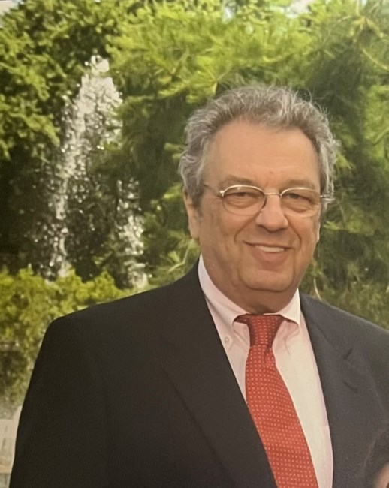
IN THE CARE OF

Parkside Memorial Chapels

It is with profound sadness that we inform you of the passing of Abraham Miller on September 2, 2023. Avi, as he was known to his friends died from complications due to a recent diagnosis of Small Cell Lung Cancer earlier this summer.
Avi was born in Poland on July 31, 1947 to Ruth and Henry Miller, two Holocaust survivors. Following his father’s death, Avi along with his mother and sister, Miriam, moved to Israel, where he lived through the completion of his IDF service. Upon moving to the United States, he studied electrical engineering and information systems, creating money transfer systems for financial institutions. He found his most joy professionally as a professor at Rutgers University, where he taught Information Management for almost 25 years.
Avi met his wife, Monica Lercher, during a Yom Kippur service in 1989, and they were married in 1994. He enjoyed spending time with his family, including antiquing in New England with Monica and watching sporting events with his daughter, Mallory. Avi loved puzzles, games, and telling jokes with his friends and family, always trying to be a positive presence in the room.
Avi considered his life to be a series of miracles, and we are so happy to have been a part of that journey.
Avi is survived by his wife, Monica, his sister, Miriam Nethaniel, and his daughter, Mallory.

