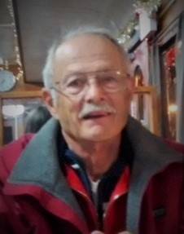
Al Reid, of Basking Ridge, NJ passed peacefully on March 8, 2022, surrounded by his wife and children. He was 81.
Born in Plainfield, Al resided in Dunellen, Mountainside, and Basking Ridge. He attended Rutgers University and after graduating was a member of the Army National Guard from 1962-1968. He became the Director of Budget and Resource Studies at Rutgers University, retiring in 2002. He stayed active by being a member of the board of his homeowners associations, both in Basking Ridge, and in Naples, Florida.
Al was an honest, kind, and hardworking man who loved spending time with his family. Al was the beloved husband of Pat Reid (Belfatto). He was the loving father of Chris and Michele. And he is survived by his cherished grandsons Michael, Matthew, and Tommy. He will be fondly remembered for his helpful nature, his goodness, and his gentleness.

Funeral Home:
Wm. A. Bradley & Son Funeral Home

Funeral:
A Memorial Service will be held on Thursday, March 17, 2022 at 11:00 a.m.
New Providence Presbyterian Church, 1307 Springfield Avenue, New Providence

Memorial Gifts:
In lieu of flowers, donations in Al’s memory can be made to the Wounded Warrior Project, P.O. Box 758516, Topeka, Kansas 66675-8516 or the Parkinson’s Foundation, 200 SE 1st Street, Suite 800, Miami, FL 33131

